On-demand Grocery WebApp
Build A Grocery Delivery App Like InstaCart, BigBasket, Walmart
The grocery delivery apps like InstaCart, Walmart, and BigBask deliver groceries packed with a lot of convenience. This combination has been helping these platforms make a revenue of millions and billions every year. In the fast-moving lifestyle of people around the world, taking time to visit the local shops and get basic groceries is no longer feasible. That’s where the prominence of on-demand grocery delivery apps can be experienced.

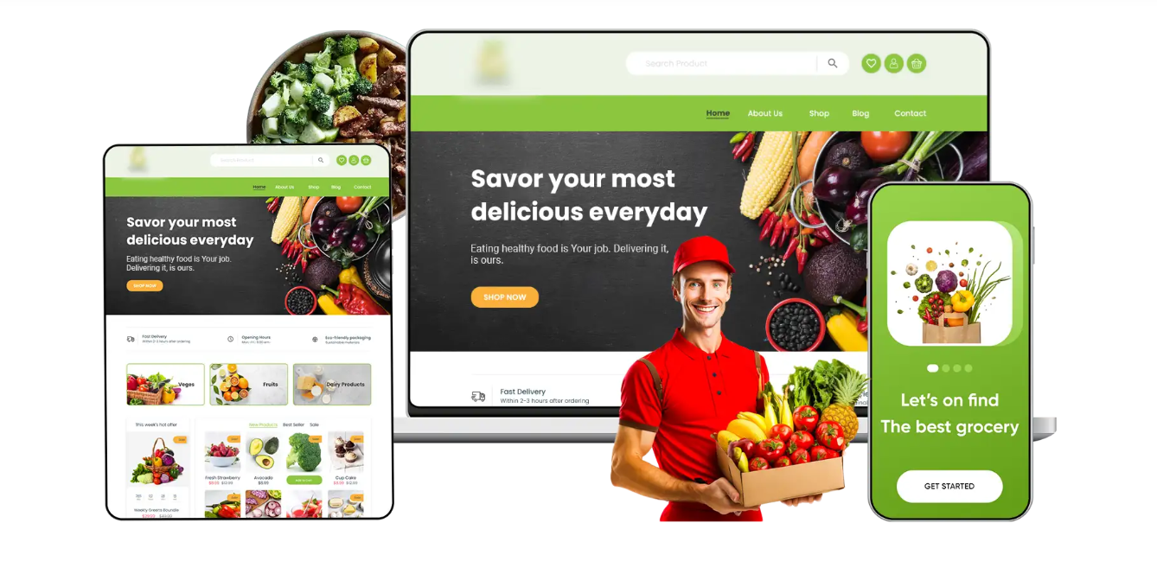

How Does the Grocery Delivery App Work?
Seamless navigation and an easy-to-use interface are the core factors behind the success of grocery delivery apps in the worldwide market.

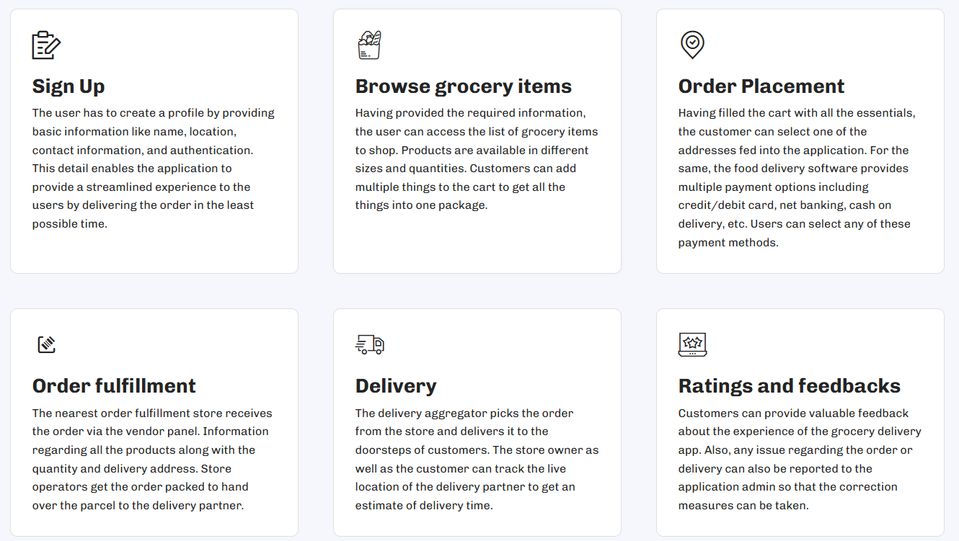

What We Offer As Grocery Delivery App Development Company?
Grocery Delivery apps are a suite of different panels working collaboratively to complete the order. The NineHertz renders the best set of technology to impart all the necessary features in the respective panels.
- Customer Panel
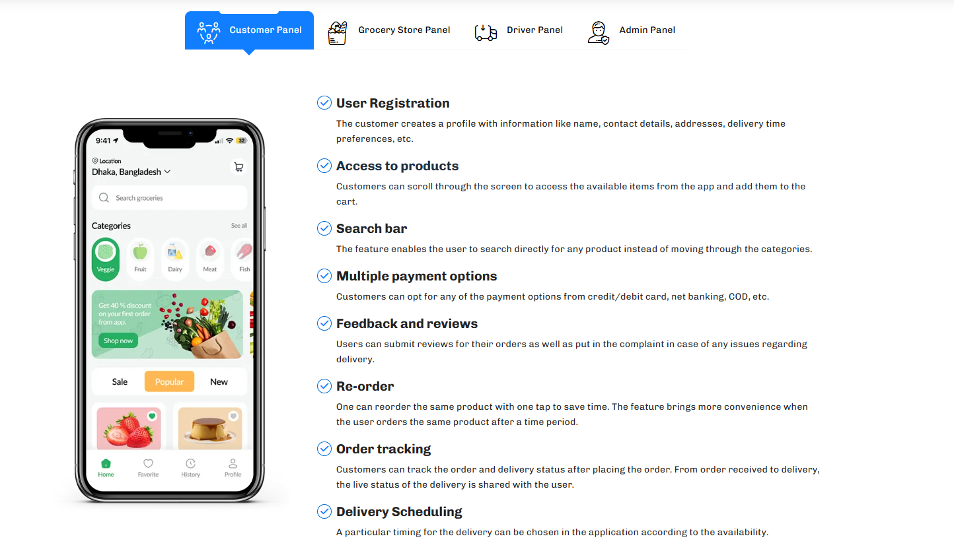
- Grocery store panel
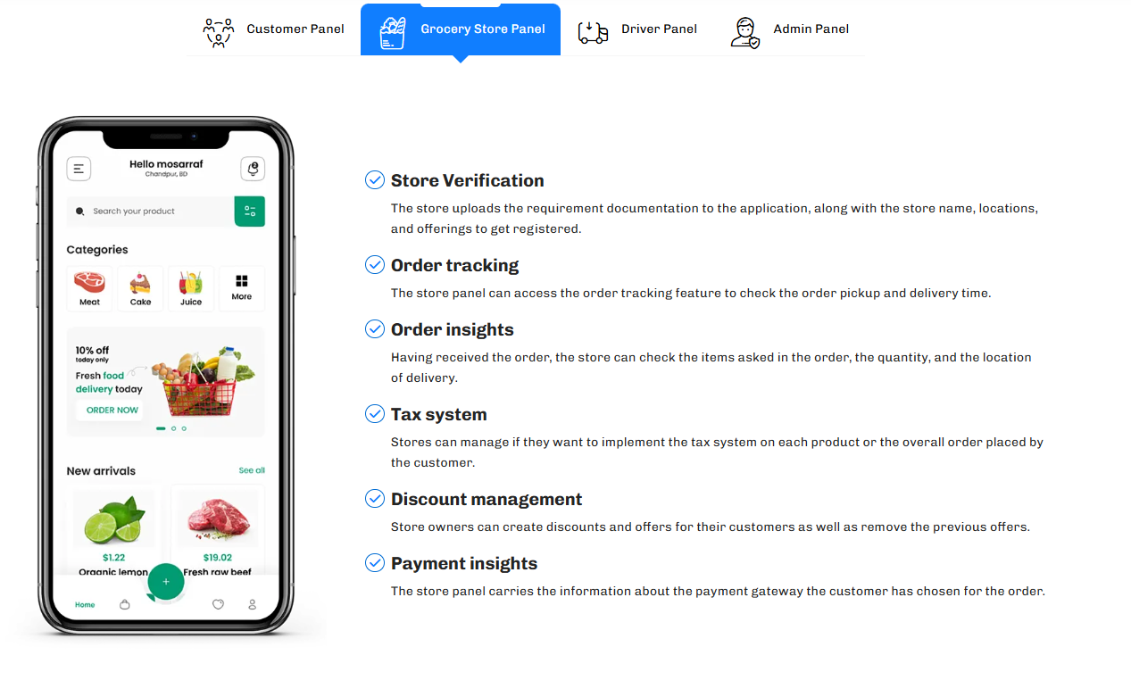
- Driver Panel
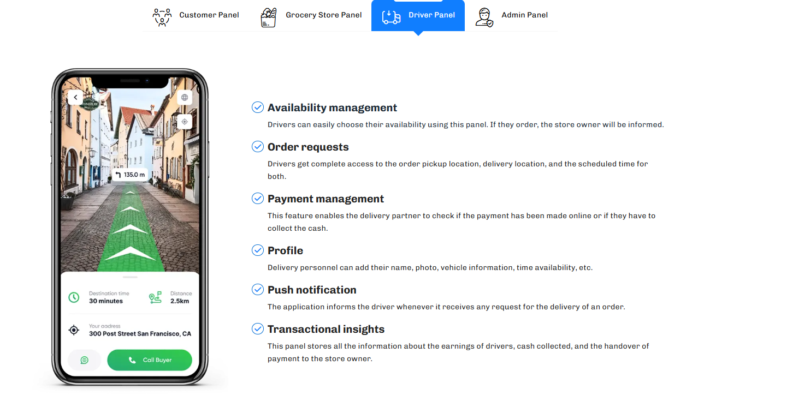
- Admin Panel
